2. ANALYTIC FUNCTIONS

Functions of a Complex Variable
Let D be a subset of C. A function f : D C is a rule that associates with each z in D a unique complex number w. We write w = f(z).
Notes
1. The set D of numbers that are mapped is called the domain of f. Notice that we now have a double use of this word. Where the domain is unspecified, we assume it to be the largest subset of C for which f(z) is defined.
2. The set of image elements {w | w = f(z)} is called the range or image of the function.
3. The above definition specifies a unique image for each z D. Later we shall extend this definition to include multivalued functions.
Examples of Functions

Example 1. f(z) = z² + iz – 3. The domain is C.
f(z) = 1/(1 + z²). Here the domain is C \ { i}.
If f(z) only assumes real values, f is real-valued.
Example 2. f(z) = |z|, f(z) = Re z = x, f(z) = Im z = y.
We can break w = f(z) into real and imaginary parts. Thus if w = u + iv, z = x + iy, then
w = f(z) = u(x, y) + iv(x, y)
Example 3. f(z) = z².
Here u + iv = (x + iy)² = (x² – y²) + 2ixy, so u = (x² – y²), v = 2xy.
This expression in terms of real and imaginary parts may be easier said than done! In theory, it allows us to deduce properties of complex functions from our knowledge of the real numbers.
Mappings
A real function y = f(x) can be represented geometrically by a graph: the set of points {(x, y) | y = f(x)}. To represent the complex function w = f(z) geometrically, in general we need four dimensions or two planes: a plane for the domain, and a plane for the range. For simple functions, we can use the same plane twice.
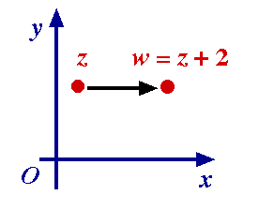
Example 1. w = f(z) = z + 2.
This is a translation:
each point z is translated through 2 to the point z + 2.

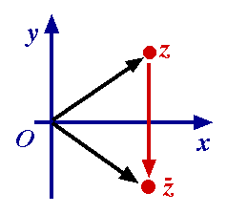
Example 2. w = f(z) = .
This is a reflection in the x-axis:
each point z = x + iy (or (x, y)) is mapped to the point = x – iy (or (x, –y)).

Mapping Curves and Regions
We shall be mapping curves and regions rather than just points.
Example
Find the image of the circle x² + y² = c² (c > 0) under w = f(z) = (x² + y²) – iy.
Let us set w = u + iv. Then each point (x, y) on the circle x² + y² = c² maps to (u, v) = (c, –y), where |y| c.
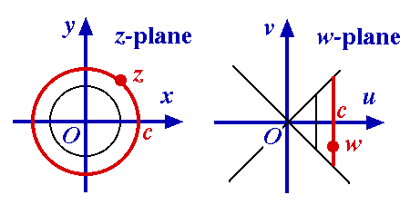
Thus the image of this circle is the line segment u = c, –c v c in the uv-plane.
The domain of f is the z-plane; the range of f is a quadrant of the w-plane.
Notice that z = (x, y) and – =(–x, y) map to the same point w.

Limits

All work on functions of two variables now carries over directly. A minor difference is that because we are dealing with complex numbers, the length or norm of a vector represented by w becomes the modulus |w| of w.
Thus the definition of limit becomes:
means
for all > 0, there exists > 0 : for all z, 0 < |z – z₀| < |f(z) – w₀| < .
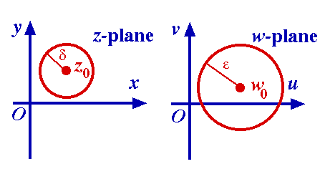
Thus every z in the left disc has an image in the right disk. We may not obtain the whole of the right disc; for example, consider the image of f(z) = constant = w₀ : this is just the central point of the second disk
A Limit Theorem (I)
Theorem 2.1 If w = f(z) = u + iv, z = x + iy, z₀ = x₀ + iy₀, then
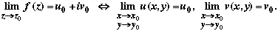
In brief, this theorem says: lim(u + iv) = lim u + i lim v.
Proof () Let us suppose that
By definition, given , there exists > 0 :
0 < |x – x₀ + i(y – y₀)| < |u(x, y) – u₀ + i(v(x, y) – v₀)| < .
We deduce that
0 < |x – x₀| < /2, 0 < |y – y₀| < /2 |u(x, y ) – u₀| < , |v(x, y) – v₀| < .
This completes this part of the proof.
A Limit Theorem (II)
( ) Now let us suppose that 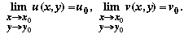
Then there exist ₁ > 0, ₂ > 0 such that
0 < |x – x₀| < ₁, 0 < |y – y₀| <₁ |u(x, y) – u₀| < /2,
0 < |x – x₀| < ₂, 0 < |y – y₀| <₂ |v(x, y) – v₀| < /2,
Choose = min(_{1,} ₂). Then using the given limits,
0 < |(x – x₀) + i(y – y₀)| <
|(u(x, y) + iv(x, y)) – (u₀ + iv₀)| |u(x, y) – u₀| + |i| |v(x, y) – v₀| < /2 + /2 <.
More Limit Theorems
Our previous theorem quickly leads to the well-known and useful Limit Theorems. We use an easy to remember abbreviated notation.
Theorem 2.2. (Limit Theorems) If lim f, lim g exist, then
lim (f g) = lim f lim g
lim (f . g) = lim f . lim g
lim (f / g) = lim f / lim g (lim g 0)
Proof (a) Set f = u + iv, lim f = u₀ + iv₀, g = U + iV, lim g = U₀ + iV₀. Now
lim (f + g) = lim (u + U + i(v + V)) (substitute and rearrange)
= lim (u + U) + i lim(v + V) (Thm 2.1)}
= u₀ + U₀ + i(v₀ + V₀) (put in the limits)
= (u₀ + iv₀) + (U₀ + iV₀) (rearrange)
= lim f + lim g.
The other proofs are similar.

Continuity
Definition Function f is said to be continuous at z₀ if f satisfies the following three conditions.
(a) f(z₀) exists ; (b) lim _{zzo} f(z) exists ; (c) lim _{zzo} f(z) = f(z₀).
Notes
1. Just writing statement (c) assumes the truth of (a) and (b).
2. Expressing (c) in terms of the limit definition, we obtain:
|z – z₀| < |f(z) – f(z₀)| < .
This is slightly different from the usual definition of limit, in that we allow the possibility z = z₀ (omitting 0 < |z – z₀| ... ).
Function f = f(z) is said to be continuous in a region if it is continuous at each point of the region.
Properties of Continuous Functions
The sum f + g, difference f – g, product f.g and quotient f/g of two continuous functions is continuous at a point z = z₀, with the proviso that in the last case g(z₀) 0. These results follow directly from the Limit Theorems 2.2.
Examples
1. Polynomial functions The polynomial function P(z) = a_{i} z ^{i} is continuous forall z since it is constructed as sums and products of the continuous constant functions (a_{i}) and the continuous function f(z) = z.
2. Rational functions The rational function P(z) / Q(z) given by the quotient of two continuous polynomial functions P(z), Q(z) is continuous for all z : Q(z) 0.

Composition of Continuous Functions
We can also compose complex functions f, g to obtain the new function f o g defined by (f o g)(z) = f(g(z)). If f, g are continuous, will f o g be continuous also?
Theorem 2.3 The composite function f o g of two continuous functions f, g is continuous.
Alternatively, a continuous function of a continuous function is a continuous function. Formally, the proof of this theorem is exactly as for the real case, and is omitted here.
Example f(z) = sin (z²) is continuous for all z.
By Theorem 2.1, f(z) = u + iv is continuous u(x, y), v(x, y) are continuous. Thus:
Example f(z) = e^{xy} + i sin(x² – 2yx³) is continuous for all z (since the real and imaginary parts are continuous).
Definition Say f is bounded in region R if |f(z)| M for all z R.
If f is continuous in R, then f is bounded because of the corresponding properties of u, v. Show this!

The Derivative
Formally, the definition of the derivative f '(z) for functions of a complex variable is the same as for real functions.
Let f be a function whose domain contains a neighbourhood of point z₀. Then
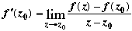
if the limit exists. In this case the function f is said to be differentiable at z₀.
It is sometimes preferable to use the alternative form of the derivative obtained by setting z = z₀ + z :
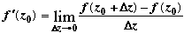
Note Since z₀ lies in an (open) neighbourhood of the domain of f, f(z₀ + z) is defined if z is small.
Examples of the Derivative
We can evaluate simple derivatives by using the basic definition.
Example f(z) = z² .
The usual differentiation formulae hold as for real variables.
For example, 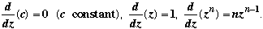
However, care is required for more unusual functions.
Example f(x) = |x|² = x² f'(x) = 2x for all x.
But f(z) = |z|² f '(z) exists only at z = 0.
This last statement is proved using the basic definition. Show it!
More on the Derivative
As in the real case, f is differentiable f is continuous.
The same rules apply for the sum, product, quotient and composite of two differentiable functions (where defined).
Example (2z² + i)⁵ = 5(2z² + i)⁴.4z = 20z(2z² + i)⁴.
Again, with more unusual functions, we may have to use the limit definition of differentiation.
Example Investigate (Re z).
We get 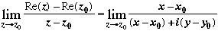
Here we get 0 approaching along x = x₀, 1 along y = y₀. Hence the limit does not exist.

QUIZ 2.4

Cauchy-Riemann Equations (I)
Theorem 2.1 gives us conditions for continuity for a function of a complex variable in terms of the continuity of the real and imaginary parts. We now ask: Is there any test for differentiability?
Theorem 2.4 The derivative f '(z) of f = u + iv exists at z the first order partial derivatives u_{x}, v_{x}, u_{y}, v_{y} all exist and satisfy
u_{x} = v_{y}, u_{y} = –v_{x} (the Cauchy-Riemann equations).
Further, f '(z) = u_{x} + iv_{x} = v_{y} – iu_{y.}
Proof Since the derivative of f exists,
Cauchy-Riemann Equations (II)
By Theorem 2.1, lim Re(*) = a, lim Im (*) = b.
Set y y₀ to get 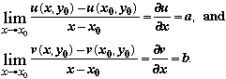
Set x x₀ to get 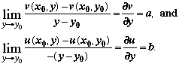
Hence all the first partial derivatives exist, u_{x} = v_{y}, u_{y} = –v_{x}, and
f '(z₀) = u_{x}(x₀, y₀) + iv_{x}(x₀, y₀) etc. as required.
Cauchy–Riemann Examples
1. Set f(z) = z² = (x + iy)² = (x² – y²) + 2ixy.
Now f'(z) = 2z exists for all z. So the Cauchy-Riemann equations are satisfied.
We have u = x² – y², v = 2xy, and u_{x} = 2x = v_{y}, u_{y} = –2y = –v_{x}.
Also f '(z) = u_{x} + iv_{x} = 2x + 2iy = 2z as expected.
2. Set f(z) = |z|². We show f '(z) does not exist for z 0.
Now f(z) = x² + y², i.e. u = x² + y², v = 0, u_{x} = 2x, u_{y} = 2y, v_{x} = 0 = v_{y}.
So u_{x} = v_{y} x = 0, u_{y} = –v_{x} y = 0.
Hence f '(z) can only exist at (0, 0).
Does f '(0) exist? Yes; as suggested earlier; we must use a first principles argument.
Sufficient Conditions
Theorem 2.4 gives necessary conditions for f to be differentiable. We now seek sufficient conditions for f ' to exist: that is, a similar statement, but using .
Theorem 2.5 Let f = u + iv as before. Suppose that
(i) u, v, u_{x}, v_{x}, u_{y}, v_{y} exist in the neighbourhood of (x₀, y₀),
(ii) u_{x}, v_{x}, u_{y}, v_{y} are continuous at (x₀, y₀),
(iii) the Cauchy-Riemann equations are satisfied at (x₀, y₀).
Then f '(z) exists and at z₀, f '(z₀) = u_{x} + iv_{x} as before.
That is, f is differentiable at z₀ the given conditions.
Proof We omit this proof. It is not hard, but rather messy.
An Example
The real functions u = e^{x} cos y, v = e^{x} sin y are defined and continuous everywhere. So are u_{x}, v_{x}, u_{y}, v_{y} and you can easily check that the Cauchy-Riemann equations are satisfied.
Hence the function f(z) = e^{x} cos y + i e^{x} sin y is differentiable everywhere.
Since u_{x} = u, v_{x} = v,
f '(z) = f(z) ( = e^{x} cis y = e^{x + iy} = e^{z}).

Analytic Functions
Definitions f(z) is analytic at z₀ if f '(z) exists not only at z₀ but for all z in some neighbourhood of z₀. f(z) is analytic in a domain of the z-plane if it is analytic at every point of the domain. f(z) is entire if it is analytic everywhere.
Examples
1. f(z) = |z|² is not analytic anywhere. (It is in fact differentiable only at z = 0).
2. f(z) = 1/z is analytic (except at z = 0).
3. f(z) = a₀ + a₁z + ... + a_{n} z^{n} is entire.
If f(z) is analytic throughout a domain except for a finite number of points, such points are singularities or singular points of f.
Examples
f(z) = 1/z (z = 0 is a singularity); 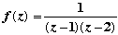 (z = 1, 2 are singularities).

Test for Analytic Functions
Question How can we tell if a function is analytic? We can use Theorem 2.5, or
Theorem 2.6: If f = f(z) is analytic, then in any formula for f, x and y can only occur in the combination x + iy.
Proof We note that x = (¹/₂)(z + ), y = (¹/_{2i})(z – ). Hence if w = f(z) = u + iv, we can regard u, v as functions of z, . Now, w is a function of z alone 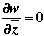and
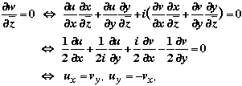
equating real, imaginary parts to zero.
Hence f analytic the Cauchy-Riemann equations hold as required.
Analytic Functions: Final Comments

Example
f(z) = sin(x + 3iy)
We can say immediately that this function is not analytic, as x and y do not occur in the combination x + iy. In some examples it is less clear whether or not the variables can be combined in this way.
Derivative Theorems
The theorems on derivatives quickly transfer to analytic functions.
Thus the sum, product, quotient and composite of two analytic functions are formed in the obvious ways as before, and each of the resulting functions is analytic on its domain.
Harmonic Functions
Let f = u + iv be analytic in some domain of z-plane. Then the Cauchy-Riemann equations hold:
u_{x} = v_{y}, u_{y} = –v_{x}
It can be shown that for analytic function, the partial derivatives of all orders exist
and are continuous functions of x, y. Hence
u_{xx} = v_{yx} and u_{yy} = –v_{xy}.
Assuming continuity of v_{yx}, v_{xy}, we have v_{yx} = v_{xy}, and hence
u_{xx} + u_{yy} = 0.
This is Laplace's equation, and u is called an harmonic function. In the same way we get
v_{xx} + v_{yy} = 0; i.e. v is an harmonic function.
If f = u + iv, u and v are conjugate harmonic functions.
(Note the different use of the word ‘conjugate’ here).
Finding Conjugate Harmonic Functions
In applied mathematics (partial differential equations) we often seek an harmonic function on a given domain which satisfies given boundary conditions. If we are given one of two conjugate harmonic functions, it is a simple matter to find the other. We use the Cauchy-Riemann equations.
Example
Let u = y³ – 3x²y. Then u is harmonic, since u_{xx} = – 6y = – u_{yy}.
Now using the Cauchy-Riemann equations, u_{x} = –6xy = v_{y}.
Integrating v partially with respect to y gives v = –3xy² + (x) and now
v_{x} = –u_{y} = –3y² +3x² '(x) = 3x².
Hence v = –3xy² + x³ + c.
You can check that v is in fact harmonic! So
f(z) = (y³ – 3x²y) + i(x³ – 3xy² + c) [= i(z³ + c) in fact].

4. MAPPING BY
ELEMENTARY FUNCTIONS

There are many practical situations where we try to simplify a problem by transforming it. We investigate how various regions in the plane are transformed by elementary analytic functions.
You may find the following website helpful:
http://www.malilla.supereva.it/Pages/Fractals/Cmapper/cm.html
Linear Functions (I)
1. w = f(z) = z + c (c = (c₁, c₂) C) – this is a translation through c.
Each z = (x, y) maps to w = (x + c₁, y + c₂).
2. Let b = | b | cis be a complex constant and let w = f(z) = bz.
If z = r cis , then w = r.| b | cis( + ).
That is, each point (r, ) maps to (| b | r, + ).
Thus we have a rotation about O through and an enlargement through | b |.
Linear Functions (II)
The general linear function is the mapping w = f(z) = bz + c.
This is the rotation and enlargement (2), followed by the translation (1)
previously discussed. That is,
z bz bz + c.
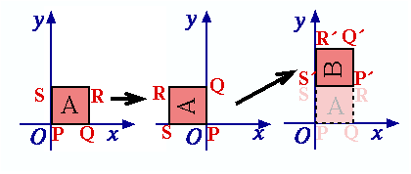
Example Consider the transformation w = iz + (i + 1).
This maps square A to square B in the adjacent figure.
Notice that S is an invariant point of this transformation.
Geometrically, we have:
rotation translation = rotation.

The Function f(z) = z² (I)
Let w = f(z) = z ². Then if z = r cis and w = cis , we have
cis = r² cis 2 and (r,) (, ) = (r²,2).
Example The first quadrant of the complex plane maps to the top half-plane under this mapping, since the angle range 0 /2 maps to the range 0 .
We note that in general, the mapping w = f(z) = z² will not be 1–1. For example, the points z both map to the same w.
The Function f(z) = z² (II)

Let us now write w = f(z) = z ² in cartesian coordinates. Setting w = u + iv, z = x + iy, we obtain u + iv = (x² – y²) + 2xyi. That is, (x, y) (x² – y², 2xy).
So z-points on the hyperbola x² – y² = k map to points on the straight line u = k.
Similarly z-points on the hyperbola 2xy = k' map to points on the straight line v = k'.
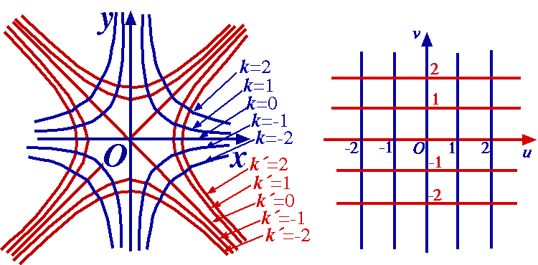

The Function f(z) = 1/z
The mapping w = f(z) =¹/_{z} (equivalently z = ¹/_{w}) sets up a 1–1 correspondence between points in the z- and w-planes excluding z = 0, w = 0.
In polar coordinates w = ¹/_{z} becomes cis = ¹/_{r} cis (–).
This transformation is the product of two simpler transformations:
z = r cis z' = ¹/_{r} cis and z' = ¹/_{r} cis w = '
– inversion in the unit circle followed by reflection in the x-axis.
Notes
1. Under inversion, the points on remain invariant.
2. Under w = ¹/_{z}, (and under inversion),
- the centre of remains invariant;
- lines through O map to lines through O;
- the interior of the exterior of ;
(in fact, circles centred at O map to circles centred at O).
Mapping Circles and Lines under f(z) = 1/z (I)
Question What is the effect of f(z) = ¹/_{z} on more general lines and circles?
Expressing w = f(z) = ¹/_{z} in terms of cartesian coordinates, we obtain
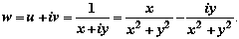
Thus
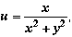 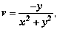 and inversely 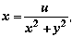 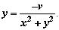
Mapping Circles and Lines under f(z) = 1/z (II)
Now consider the equation
a(x² + y²) + bx + cy + d = 0 (a, b, c ,d R). (*)
If a 0, this is the equation of a circle; if a = 0, the equation of a straight line.
Substituting for x, y in terms of u, v we get
d(u² + v²) + bu – cv + a = 0 (†)
Points (u, v) satisfying (†) correspond to points (x, y) satisfying (*). Hence we have the four cases:
(a) a 0, d 0. Circle not through O circle not through O.
(b) a 0, d = 0. Circle through O straight line not through O.
(c) a = 0, d 0. Straight line not through O circle through O.
(d) a = 0, d = 0. Straight line through O straight line through O.
Example of a Mapping under f(z) = 1/z
What is the image under w = f(z) = ¹/_{z} of line x = c?
The line x = c maps to the set of points satisfying
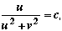 that is, u² + v² – ^{u}/_{c} = 0, or (u – ¹/_{2c})² + v² = (¹/_{2c})².
This is the circle with centre (¹/_{2c}, 0), passing through the origin O.
The half plane x > c maps to the interior of the disc.
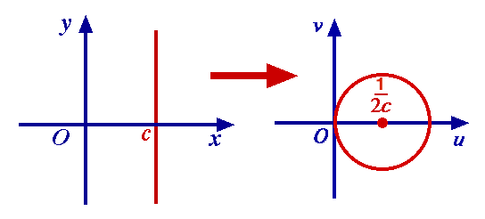

Bilinear Transformations
Let T be the transformation 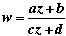, (ad – bc 0, a, b, c, d C).
This is called a bilinear transformation as it can be rewritten as
cwz + dw – az – b = 0
– an equation which is linear in each of its variables, z and w.
Solving for w in terms of z, we see that the inverse of T is another bilinear transformation:
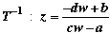.
Notes
1. The singular points for T, T^{–1} are z = –d/_{c}, w = ª/c respectively.
As each mapping has just one singular point, we write
z = –^{d}/_{c} ‘w = ’, w = ª/_{c} ‘z = ’.
2. The set of bilinear transformations forms a group.
Understanding the Bilinear Transformation
In the formula for a bilinear transformation, if c 0, we can write
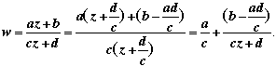
Setting z' = cz + d, z'' = ¹/_{z'}, we obtain
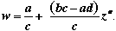 (*)
If c = 0, we get an expression of type (*) immediately.
It follows that any bilinear transformation can be obtained as the composition of linear transformations and the mapping f(z) = ¹/_{z} , all of which map lines and circles to lines and circles.
Hence any bilinear transformation maps the set of lines and circles to itself.
Images under a Bilinear Transformation
The following reult will be useful.
Theorem 4.1 There exists a unique bilinear transformation which maps three given distinct points z₁, z₂, z₃ onto three distinct points w₁, w₂, w₃ respectively.
Proof The algebraic expression for the bilinear transformation can be written as
cwz + dw – az – b = 0. This is an equation in four unknowns a, b, c, d. Hence the three ratios a : b : c : d of these numbers are determined by substituting three pairs of corresponding values of z_{i}, w_{i} (1 i 3).
In practice, this means that in general if we allocate image points to three points in the z-plane, then the bilinear transformation will be completely determined. Conversely, if we want to find the image of a circle (say) under a given bilinear transformation, then it is sufficient to find the images of three points on the circle.
Bilinear Transformation: Example
Let a C be constant with Im a > 0. Find the image of the upper half plane (y 0) under the bilinear transformation
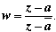.
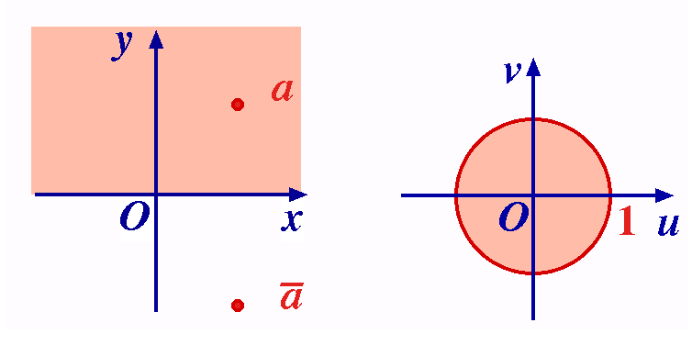
We first consider the boundary. For z on x-axis, we have | z – a | = | z – |.
Hence for such points, 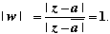.
That is, the x-axis maps to the unit circle having centre O.
Also, z = a (a point in the upper half plane) maps to w = 0 (a point interior to the unit circle). Observing that the mapping is continuous, we deduce that the image of the upper half plane is the interior of the disc.

The Transformation w = exp z
As before, we set z = x + iy, w = cis and w = exp z gives = e^{x} and = y.
The line y = c maps onto the ray = c (excluding the end-point O) in a 1–1 fashion. Similarly, the line x = c maps onto the circle = e^{c}. However, here, an infinite number of points on the line map to each image point.
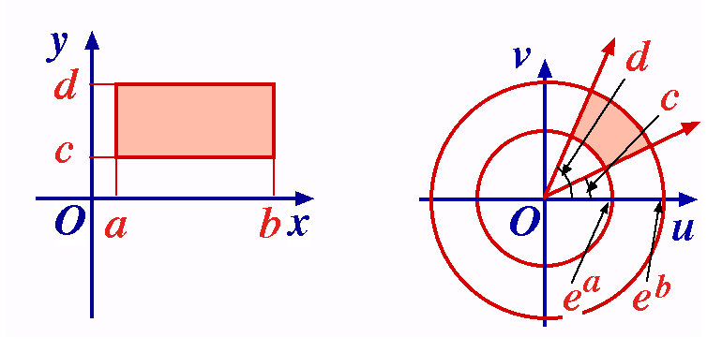
Combining these results, we see that the rectangular region
a x b, c y d
is mapped to the region
eª e^{b}, c d
bounded by portions of circles and rays.
This mapping is 1–1 if d – c < 2.
A Special Case of w = exp z
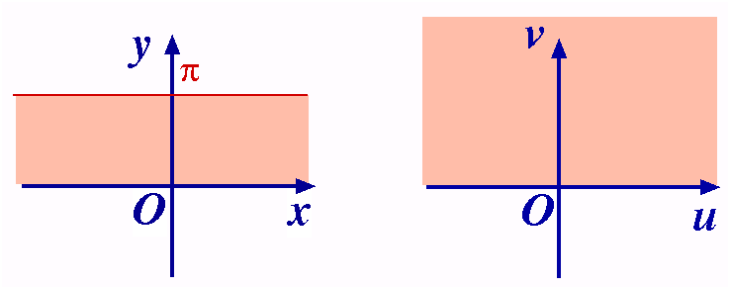
As a particular case, the strip 0 < y < maps to the upper half plane > 0, 0 < < of the w-plane.
It is interesting to map the boundary points here. This mapping is useful in applications.

4. MAPPING BY
ELEMENTARY FUNCTIONS

There are many practical situations where we try to simplify a problem by transforming it. We investigate how various regions in the plane are transformed by elementary analytic functions.
You may find the following website helpful:
http://www.malilla.supereva.it/Pages/Fractals/Cmapper/cm.html
Linear Functions (I)
1. w = f(z) = z + c (c = (c₁, c₂) C) – this is a translation through c.
Each z = (x, y) maps to w = (x + c₁, y + c₂).
2. Let b = | b | cis be a complex constant and let w = f(z) = bz.
If z = r cis , then w = r.| b | cis( + ).
That is, each point (r, ) maps to (| b | r, + ).
Thus we have a rotation about O through and an enlargement through | b |.
Linear Functions (II)
The general linear function is the mapping w = f(z) = bz + c.
This is the rotation and enlargement (2), followed by the translation (1)
previously discussed. That is,
z bz bz + c.
Example Consider the transformation w = iz + (i + 1).
This maps square A to square B in the adjacent figure.
Notice that S is an invariant point of this transformation.
Geometrically, we have:
rotation translation = rotation.

The Function f(z) = z² (I)
Let w = f(z) = z ². Then if z = r cis and w = cis , we have
cis = r² cis 2 and (r,) (, ) = (r²,2).
Example The first quadrant of the complex plane maps to the top half-plane under this mapping, since the angle range 0 /2 maps to the range 0 .
We note that in general, the mapping w = f(z) = z² will not be 1–1. For example, the points z both map to the same w.
The Function f(z) = z² (II)

Let us now write w = f(z) = z ² in cartesian coordinates. Setting w = u + iv, z = x + iy, we obtain u + iv = (x² – y²) + 2xyi. That is, (x, y) (x² – y², 2xy).
So z-points on the hyperbola x² – y² = k map to points on the straight line u = k.
Similarly z-points on the hyperbola 2xy = k' map to points on the straight line v = k'.

The Function f(z) = 1/z
The mapping w = f(z) =¹/_{z} (equivalently z = ¹/_{w}) sets up a 1–1 correspondence between points in the z- and w-planes excluding z = 0, w = 0.
In polar coordinates w = ¹/_{z} becomes cis = ¹/_{r} cis (–).
This transformation is the product of two simpler transformations:
z = r cis z' = ¹/_{r} cis and z' = ¹/_{r} cis w = '
– inversion in the unit circle followed by reflection in the x-axis.
Notes
1. Under inversion, the points on remain invariant.
2. Under w = ¹/_{z}, (and under inversion),
- the centre of remains invariant;
- lines through O map to lines through O;
- the interior of the exterior of ;
(in fact, circles centred at O map to circles centred at O).
Mapping Circles and Lines under f(z) = 1/z (I)
Question What is the effect of f(z) = ¹/_{z} on more general lines and circles?
Expressing w = f(z) = ¹/_{z} in terms of cartesian coordinates, we obtain
Thus
and inversely
Mapping Circles and Lines under f(z) = 1/z (II)
Now consider the equation
a(x² + y²) + bx + cy + d = 0 (a, b, c ,d R). (*)
If a 0, this is the equation of a circle; if a = 0, the equation of a straight line.
Substituting for x, y in terms of u, v we get
d(u² + v²) + bu – cv + a = 0 (†)
Points (u, v) satisfying (†) correspond to points (x, y) satisfying (*). Hence we have the four cases:
(a) a 0, d 0. Circle not through O circle not through O.
(b) a 0, d = 0. Circle through O straight line not through O.
(c) a = 0, d 0. Straight line not through O circle through O.
(d) a = 0, d = 0. Straight line through O straight line through O.
Example of a Mapping under f(z) = 1/z
What is the image under w = f(z) = ¹/_{z} of line x = c?
The line x = c maps to the set of points satisfying
that is, u² + v² – ^{u}/_{c} = 0, or (u – ¹/_{2c})² + v² = (¹/_{2c})².
This is the circle with centre (¹/_{2c}, 0), passing through the origin O.
The half plane x > c maps to the interior of the disc.

Bilinear Transformations
Let T be the transformation , (ad – bc 0, a, b, c, d C).
This is called a bilinear transformation as it can be rewritten as
cwz + dw – az – b = 0
– an equation which is linear in each of its variables, z and w.
Solving for w in terms of z, we see that the inverse of T is another bilinear transformation:
.
Notes
1. The singular points for T, T^{–1} are z = –d/_{c}, w = ª/c respectively.
As each mapping has just one singular point, we write
z = –^{d}/_{c} ‘w = ’, w = ª/_{c} ‘z = ’.
2. The set of bilinear transformations forms a group.
Understanding the Bilinear Transformation
In the formula for a bilinear transformation, if c 0, we can write
Setting z' = cz + d, z'' = ¹/_{z'}, we obtain
(*)
If c = 0, we get an expression of type (*) immediately.
It follows that any bilinear transformation can be obtained as the composition of linear transformations and the mapping f(z) = ¹/_{z} , all of which map lines and circles to lines and circles.
Hence any bilinear transformation maps the set of lines and circles to itself.
Images under a Bilinear Transformation
The following reult will be useful.
Theorem 4.1 There exists a unique bilinear transformation which maps three given distinct points z₁, z₂, z₃ onto three distinct points w₁, w₂, w₃ respectively.
Proof The algebraic expression for the bilinear transformation can be written as
cwz + dw – az – b = 0. This is an equation in four unknowns a, b, c, d. Hence the three ratios a : b : c : d of these numbers are determined by substituting three pairs of corresponding values of z_{i}, w_{i} (1 i 3).
In practice, this means that in general if we allocate image points to three points in the z-plane, then the bilinear transformation will be completely determined. Conversely, if we want to find the image of a circle (say) under a given bilinear transformation, then it is sufficient to find the images of three points on the circle.
Bilinear Transformation: Example
Let a C be constant with Im a > 0. Find the image of the upper half plane (y 0) under the bilinear transformation
.
We first consider the boundary. For z on x-axis, we have | z – a | = | z – |.
Hence for such points, .
That is, the x-axis maps to the unit circle having centre O.
Also, z = a (a point in the upper half plane) maps to w = 0 (a point interior to the unit circle). Observing that the mapping is continuous, we deduce that the image of the upper half plane is the interior of the disc.

The Transformation w = exp z
As before, we set z = x + iy, w = cis and w = exp z gives = e^{x} and = y.
The line y = c maps onto the ray = c (excluding the end-point O) in a 1–1 fashion. Similarly, the line x = c maps onto the circle = e^{c}. However, here, an infinite number of points on the line map to each image point.
Combining these results, we see that the rectangular region
a x b, c y d
is mapped to the region
eª e^{b}, c d
bounded by portions of circles and rays.
This mapping is 1–1 if d – c < 2.
A Special Case of w = exp z
As a particular case, the strip 0 < y < maps to the upper half plane > 0, 0 < < of the w-plane.
It is interesting to map the boundary points here. This mapping is useful in applications.

